MALDIVES – THE SUNNY SIDE OF LIFE

Sun, sand and sea, a thousand ‘Robinson Crusoe’ islands, massive lagoons with different depths and infinite shades of blue and turquoise, dazzling underwater coral gardens; a perfect natural combination for the ideal tropical holiday destination. However there is more to the Maldives than just that.

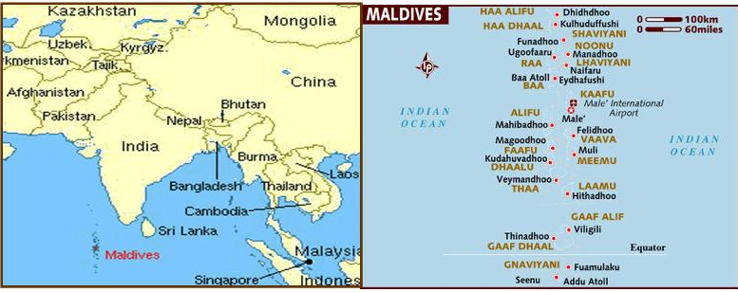

LOCATION : Southwest of Sri Lanka, on the equator.
Geography
1,190 coral islands, forming an archipelago of 26 major atolls. 87 are exclusive resort islands.
VISA REQUIREMENTS :
Free 30 days Visa upon arrival for all visitors
No prior visa is required to enter the Republic of Maldives. Entry permit will be granted to visitors on arrival at designated ports of entry, based on the immigration requirements

HOW TO GET THERE :
International Airport : Male is the only International Airport here.

Flights into Male :
From India, 2 airlines connect to Maldives :

Indian Airlines (IC) : Schedule – TRV/MLE/TRV and BLR/MLE/BLR
Srilankan Airlines (UL) : Schedule – CMB/MLE/CMB

CURRENCY :
The unit of Maldivian currency is the Rufiyaa (MRF), which is divided into one hundred Laari.
US Currency is widely accepted.

GETTING AROUND :

Transport from the Airport :

Ferry Service to the Capital : A ferry service is available from the airport island to the capital around the clock. A special dhoni ferry leaves from the airport jetty to the capital every 15 minutes which changes to one every 30 minutes after midnight.Since the airport island is geographically separate from the capital the only means of transport to the Capital is by Sea. If required, a dhoni can be chartered by for transfer to the capital at set rates. Further details cab be attained from the ferry terminal at the jetty of the airport.

Air Transport :
Maldivian Air Taxi and Trans Maldivian Airways operate special air transfer trips to most of the resorts. This mode of transport is best arranged by your agents or the resort operative. Normally resort operators have arrangements for chartered flights to their resort with either of these parties. Please consult your Travel Agent or the resort operative regarding transfer arrangements.

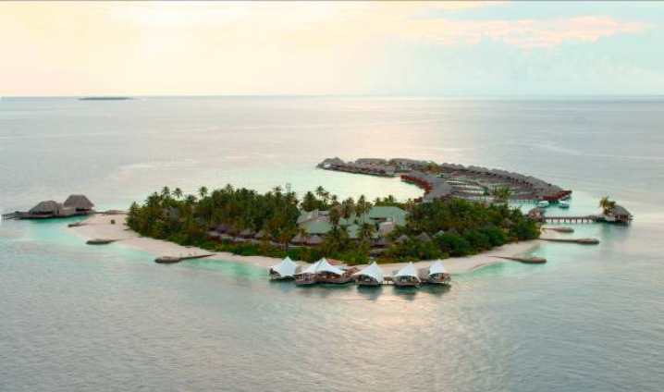

BUISNESS HOURS :
From Sunday to Thursday 7.30 - 14.30 in the government sector and generally from 9.00 to 5.00 in the private sector, although most offices in the private sector open for a half day on Saturday. Weekend falls on Friday and Saturday.

CLIMATE :
The climate is warm and tropical throughout the year with cooling sea breezes. Daily temperatures vary between 26°C and 32°C. Even during the monsoon months (south-west from April to October and northeast from December to March) there is seldom more than a few days of rain at a time.

CLOTHING :
Dress is generally casual. T-shirts and cotton clothing are most suitable. In Male’, the capital island and other inhabited islands it is recommended that women wear modest clothing without baring too much

TIME DIFFERENCE :
Maldives is 0.30 minutes behind us.

ELECTRICITY:
The electric system is 230-240 Volts –AC

DIALLING CODE :
+960

LANGUAGE :
Dhivehi is the language spoken in all parts of the Maldives. English is widely spoken by Maldivians and visitors can easily make themselves understood getting around the capital island.

RELIGION :
Maldives is a Sunni Muslim nation.

INFORMATIVE WEBSITE :
www.visitmaldives.com

CITY :
MALE :
Male' is the hub of the Male' Atoll (2,430 sq.miles.), comprising of the old North and South Male' Atolls. In this chain, stretching for over 62 miles from north to south, only ten islands apart from the capital are inhabited.
Different from any other island in the country, Male’ is a city of high-rise buildings and paved roads. While the government offices are located in one area, the main streets are lined with shops and offices

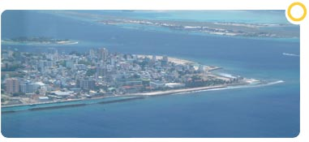

MUST SEES :
Hukuru Miskiiy
Built in the 17th century the Huskuru Miskiiy or Friday Mosque served the population of Male’ as their main mosque for almost four centuries, until the Islamic Centre and Grand Friday Mosque took over the function in 1984. The mosque is a masterpiece of coral curving and traditional workmanship - probably the best display of coral curving anywhere in the world. The walls of the mosque are hewn together with blocks of filigree-curved coral blocks. Heavy wooden doors slide open to the inner sanctums with lamp hangings of wood and panels intricately curved with Arabic writings. The area surrounding the mosque is a cemetery with a legion of intricately curved coral headstones.

The Islamic Centre
The Islamic Centre is the most vivid architectural landmark of Male’. You would see the spectacular golden dome in all its majesty dominating the skyline, as you approach Male’, from any direction. The building symbolizes the importance of Islamic religion, which had ruled all aspects of life in the country for centuries. Completed in 1984, the Centre consists of a mosque big enough for 5000 people, an Islamic library, conference hall, classrooms and offices
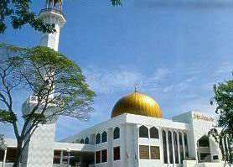

Mulee Aage
Right in front of the Hukuru Miskiiy is Mulee-aage, a palace built in 1906 by Sultan Mohamed Shamsuddeen III, replacing a house dating back to the mid-17th century. At present Mulee-aage houses the President’s Office.
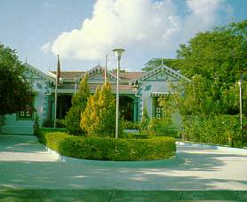

The National Museum
The National Museum is housed in the only remaining building of the former Sultan’s Palace, which is now the Sultan’s Park. It is an Edwardian colonial-style building of three storey, fairly low key from the outside compared to the amazing collection inside. The articles on display range from thrones and palanquins used by former sultans to the first printing press used in the country, ceremonial robes, headgear and umbrellas used by Sultans to statues and other figures dating from 11th century, excavated from former temples. A variety of artifacts from times past would give an idea of the unique and rich culture and history of this island nation. A visit to the museum gives an instant insight to the wealth of history most visitors never suspect existed. No longer will you think of the Maldives solely in terms of a tourist destination. The museum is open daily except Friday and public holidays from 9.00 to 11.40 and 3.00 to 5.40. A small fee is charges for admission.

CHECK OUT :
Hilton Hotel’s Undersea Restaurant :
There’s the intimate (and famous!) Ithaa Undersea Restaurant located five metres below sea level. Here you can enjoy Maldivian-Western fusion cuisine whilst marvelling at the 360
degree views of reef and marine life.

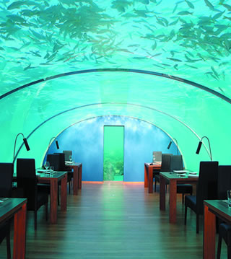

THINGS TO DO :
Not only do you discover aspects of the planet denied to most people, but you make a lot of good friends as well!
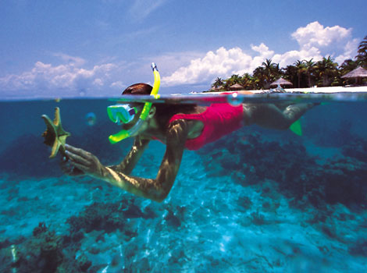

The Maldives is famed for its rare underwater beauty. The profusion of psychedelic colours and the abundance and variety of life underwater have fascinated divers and snorkellers since Maldives was discovered as a diving destination. The highest level of visibility that one could expect- sometimes exceeding 50 metres - and warm temperatures throughout the year makes diving in the Maldives a delight you would want to experience over and over again. The Maldives has some of the best dive sites in the world and many visit the Maldives repeatedly for the sole purpose of diving.All resorts in the Maldives have professional dive schools with multi-lingual instructors and conduct courses for beginners as well as the advanced. Many of the resorts have excellent house reefs. Just a short swim from the beach and snorkellers too can experience the same pleasures from the surface.
SHOPPING AND MUST-BUYS :
Garments and Electronics :
Shopping is the favorite activity for the locals especially in the evenings, when it is cooler. The Majeedhee Magu, which is the main road on the island, has along its sides various shops selling goods from the smallest commodities to virtually everything you could think of. The shops are well stocked with garments, perfumes and cosmetics, jewelry, watches or electronics, to name just a few. Many find it a pleasant experience to join the throngs of shoppers on the main shopping streets in the evenings. All shops are open until 11.00 in the night, except for prayer times, when they are closed for 15 minutes.

Souvenirs
It is not difficult to find your way around Male’, especially if you carry a map with you. After all it is only two square kilometers. The main street Majeedhee Magu, runs right across the island from east to west. Chaandhanee Magu on the other hand runs from north to south. Most souvenir shops line the northern end of Chaandanee Magu, earlier known as the Singapore Bazaar for its many imports from Singapore. Guides and vendors speaking in English and other foreign languages patiently wait to serve the visitors. These shops are stocked with an ample supply of gifts and souvenir items. Best buys include the ‘thudu kuna’ the Maldivian mat woven with local natural fibers. Attractive too are the wooden miniature ‘dhonis’. When shopping for souvenirs, do keep in mind that export of products made of turtle shell, black coral, pearl oyster shell and red coral is prohibited.

